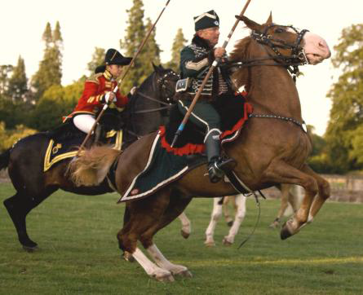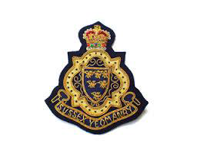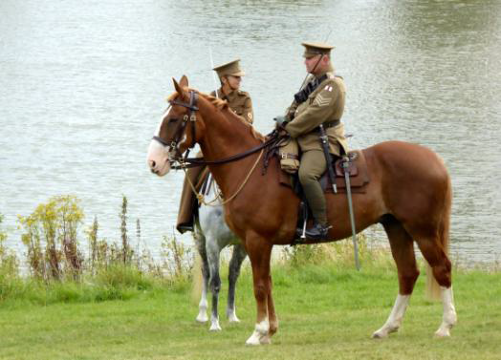

Sussex Yeomanry
HISTORY….HORSES….EDUCATION....FUN

Mounted Skill at arms/tentpegging – taught and displayed by the master!

Download their information sheet here. It tells you what they are available to do, i.e. give demonstrations, attend corporate events, add a different dimension to educational workshops, weddings, etc. and host competitions.

Also see the new Sussex Yeomanry website at http://sussexyeomanry.uk and find them on Facebook and Twitter

